16. Create an EC2 instance with 8 GB storage.

17. Create a snapshot for the EC2 instance's EBS volume.

18. Extend storage by an additional 8 GB for the running instance.

19. Delete the snapshot created earlier.

20. Instructions on how to connect to an EC2 instance if the PEM key is lost.

21. Create instance-1 in ap-south-1a with an 8 GB volume.

22. Create instance-2 in ap-south-1b with an 8 GB volume.

23. Stop and detach the EBS volume from instance-1 and attempt to attach it to instance-2. Determine if this is possible and under what conditions (hint: it depends on the specific volume type created). Find a solution for this scenario.

16. Create an EC2 instance with 8 GB storage.

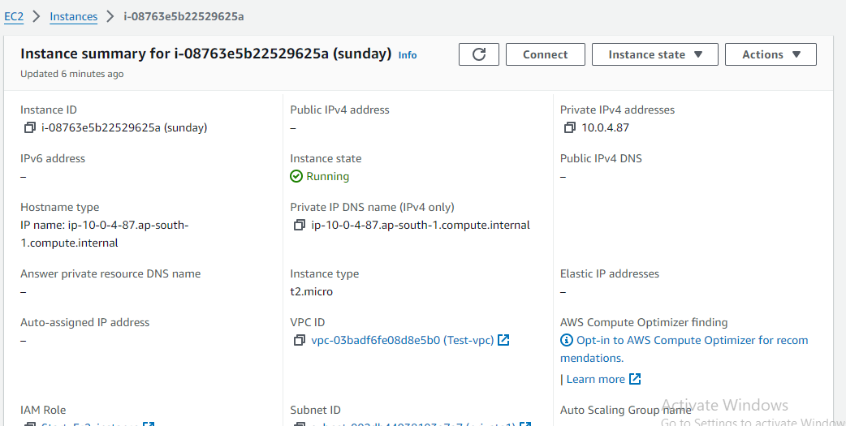

17.Create a snapshot for the EC2 instance's EBS volume.

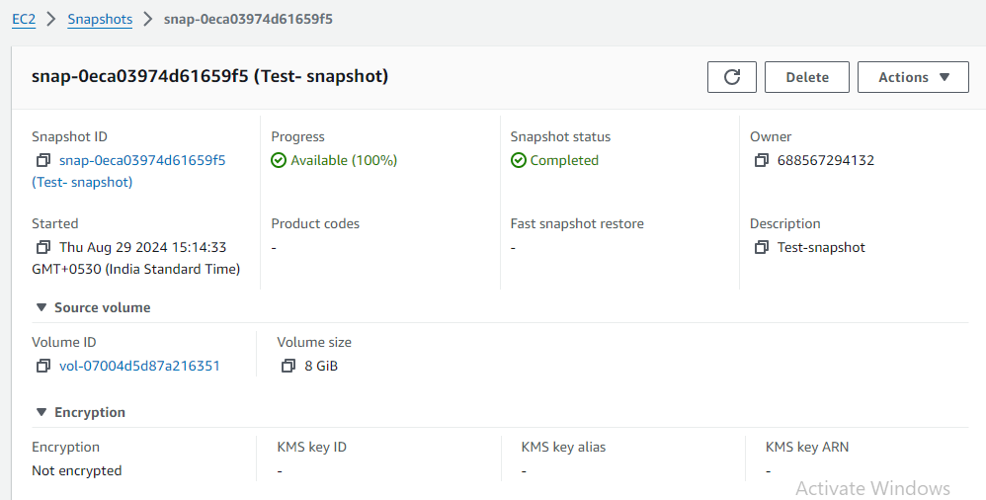

18. Extend storage by an additional 8 GB for the running instance.

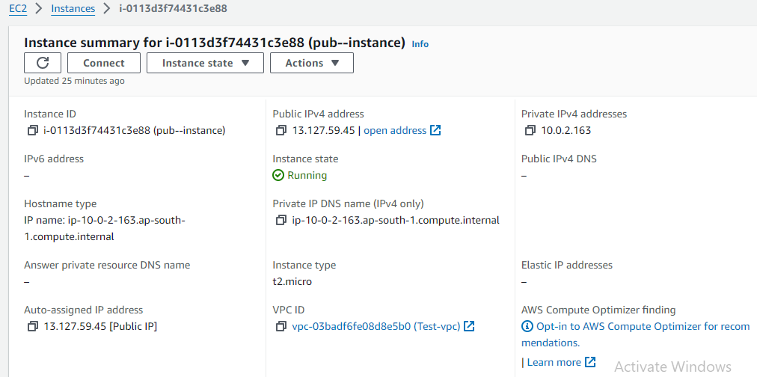

19. Delete the snapshot created earlier.

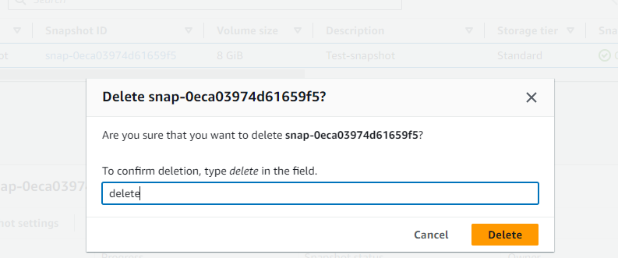

20. Instructions on how to connect to an EC2 instance if the PEM key is lost with images

Create an new instance-3 and some connect(with file f1 and file f2)in the this instance

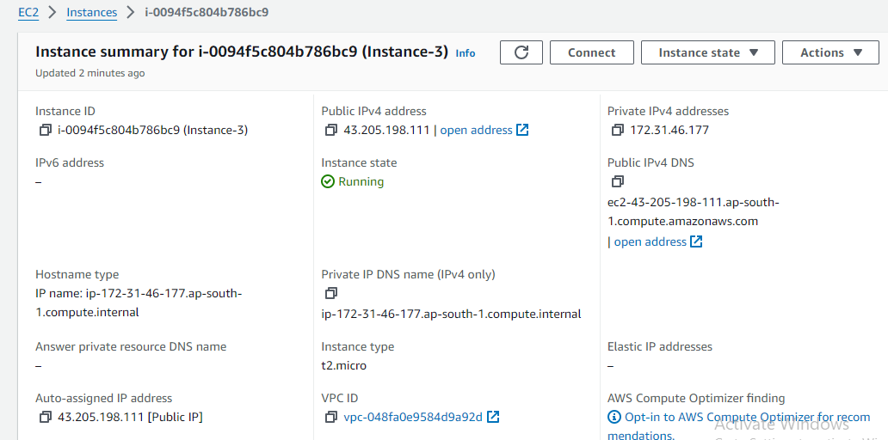

Stopted the created instance

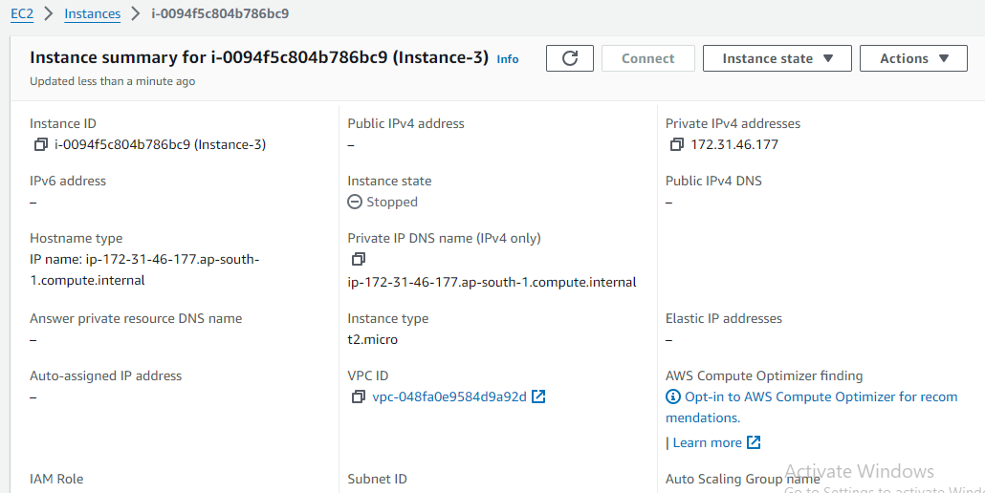

Detached the volume of instanve-3

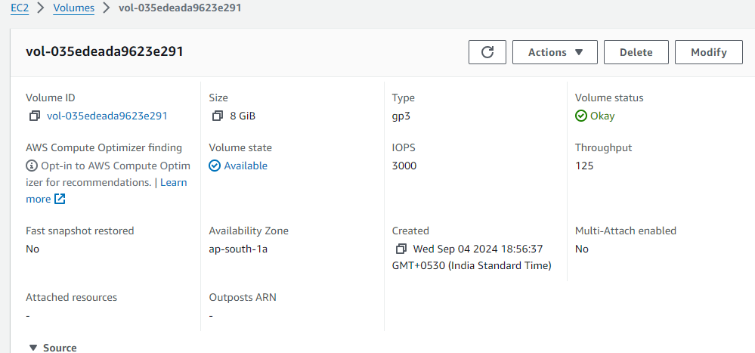

Created a new instance with instance-3 and attach the detached volume to the new

With device name /dev/sdd

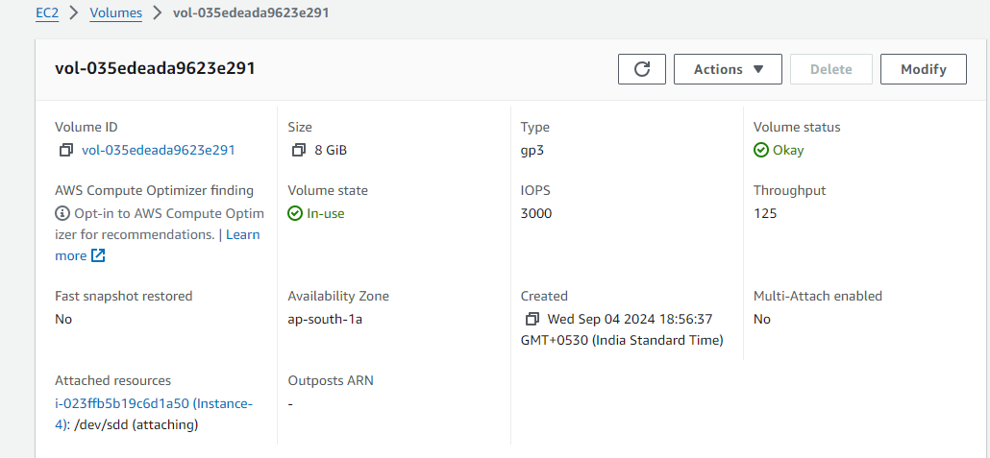

After attaching the detached volume of instance-3.The content in instance-3 be displaying

In the instance-4

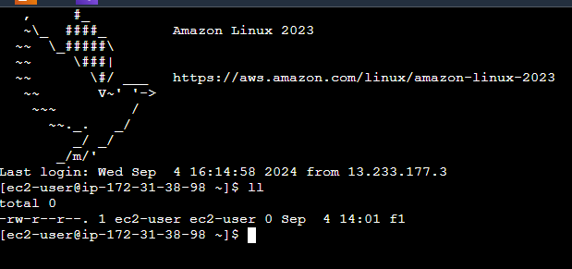

21. Create instance-1 in ap-south-1a with an 8 GB volume.

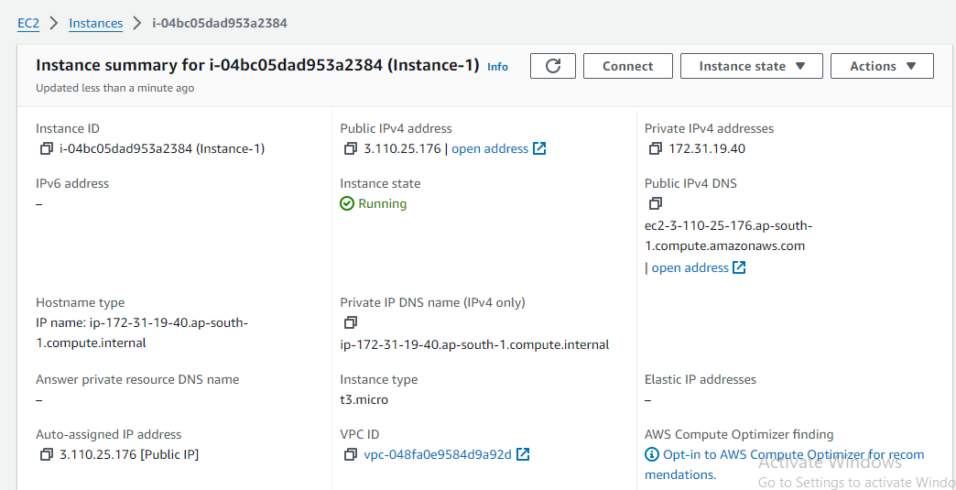

Volume of instance-1

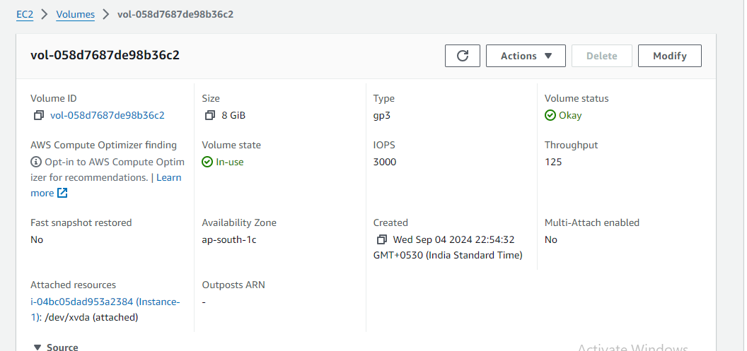

22. Create instance-2 in ap-south-1b with an 8 GB volume.

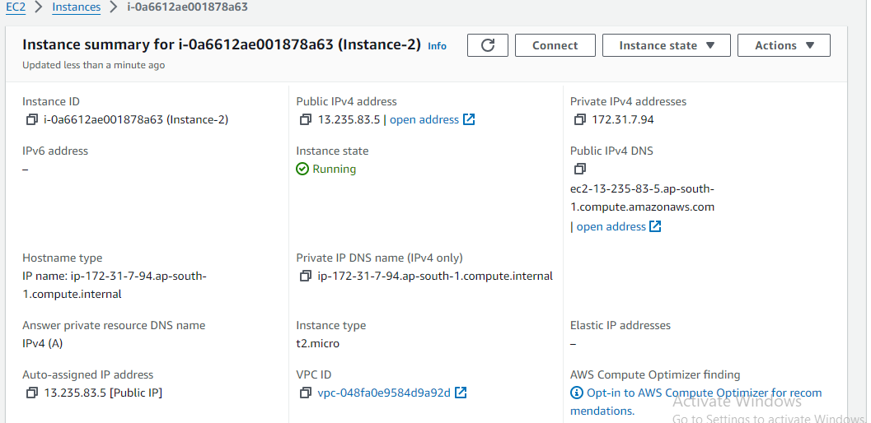

Volume of Instance-2

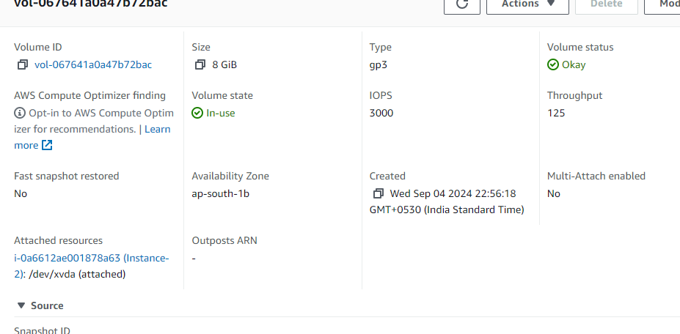

23. Stop and detach the EBS volume from instance-1 and attempt to attach it to instance-2. Determine if this is possible and under what conditions (hint: it depends on the specific volume type created). Find a solution for this scenario.

Stop and detach the EBS volume from instance-1 and it is not posible in different availability zones to attach it to instance-2

* Create the snapshot of using volume-1 before detach the volume-1

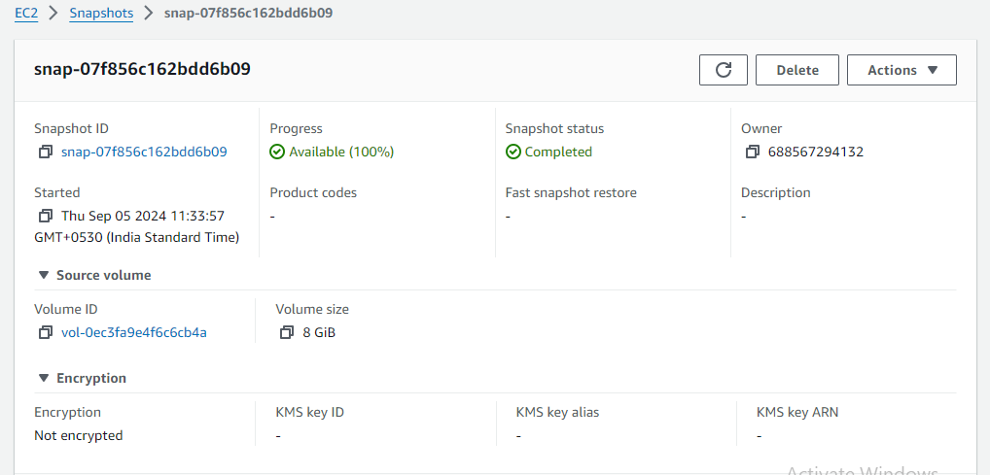

* Go to instance and stop the instsance-1

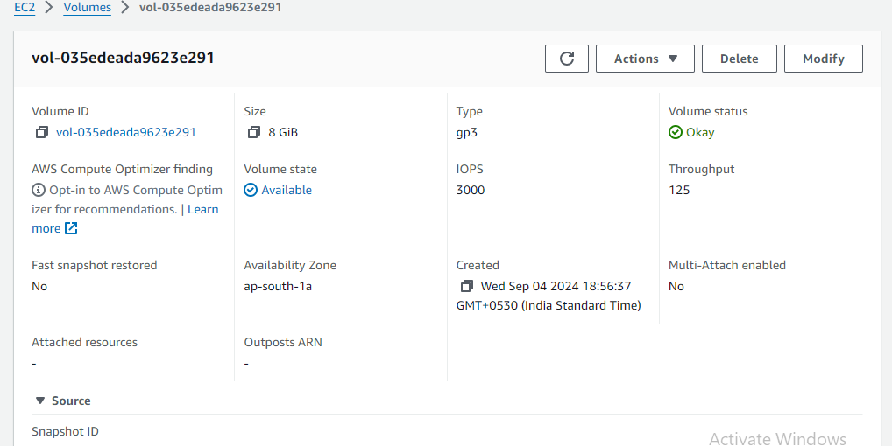

* Detach the volume of instance0-1

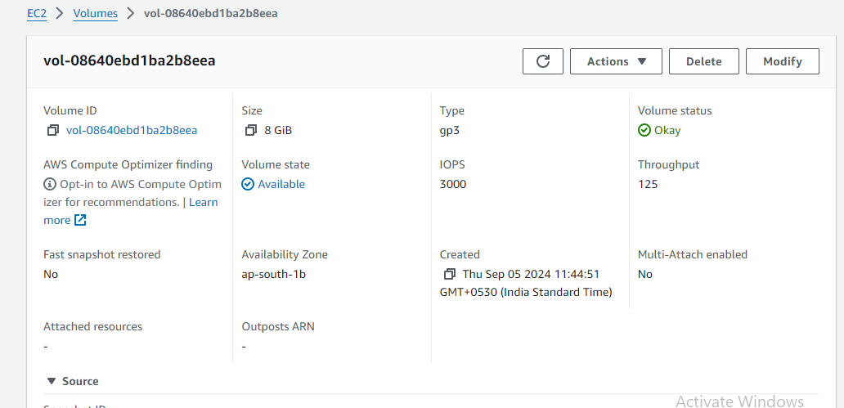

* Now create the volume from snapshot

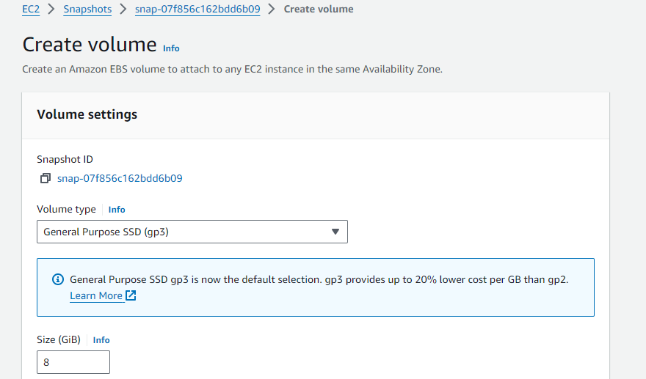

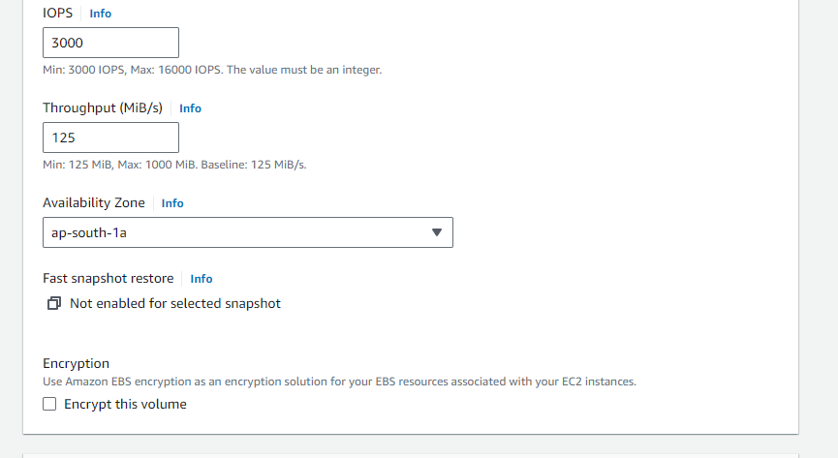

* After creating the volume from snapshot attach the voliume to the instance-2

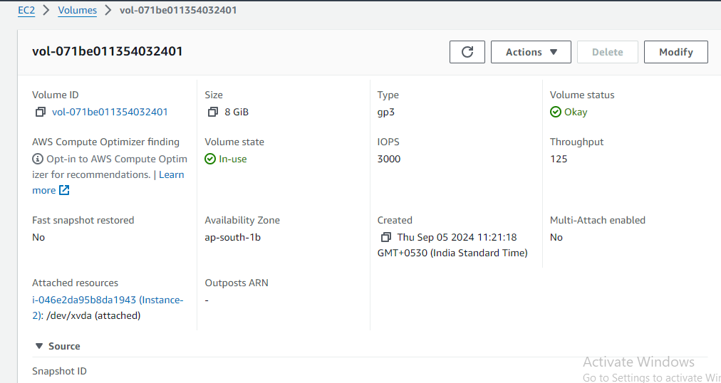

* After attaching the volume to the instance-2 the content in the instance-1 be converted to the instance-2

